To | : | Mr. Charlie Luk, Cluster Human Resources, 4/F Rehab Block, TMH
Fax | : | 2461 2396
Tel | : | 3767 7006
Email | : | Charlie LUK, NTWC TSA(T&D)B3
Deadline Enrolment: 30 APR 2011

Enrolment Form
Interventional Pain Workshop

Date: 12th May, 2011 (Thursday)
Time: 9:00 am – 5:00 pm
Venue: Auditorium, 1/F Pok Oi Hospital, NTW Cluster
Target audience: The interested medical and health care staff

Section to be completed by departments or individual attendee

No. | Department | Name | Title | Contact Number
1
2
3

Submitted by:

Hospital | : |  |  | Date | :
Name | : |  |  | Position/Title | :
Email | : |  |  | Telephone | :

Remarks
Limited car park can be provided and shuttle bus transport from MTR station are available. Please provide the car plate no. by e-mail to reserve car park.

Do you need Shuttle Bus at Yuen Long MTR station*?
Please circle: Yes / No If yes, no. of persons:________________
*參閱附件一
CPD/CNE points are pending
The course is Free of Charge

附件一
Exit G1落扶手電梯

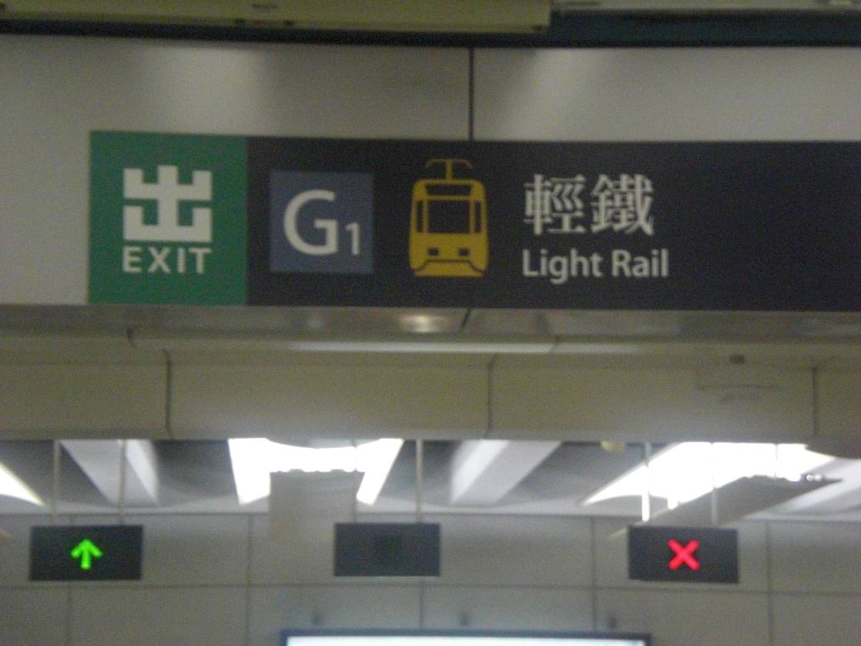

左轉步向輕鐵總站前, 再左轉步向(不能停車過久)落客區
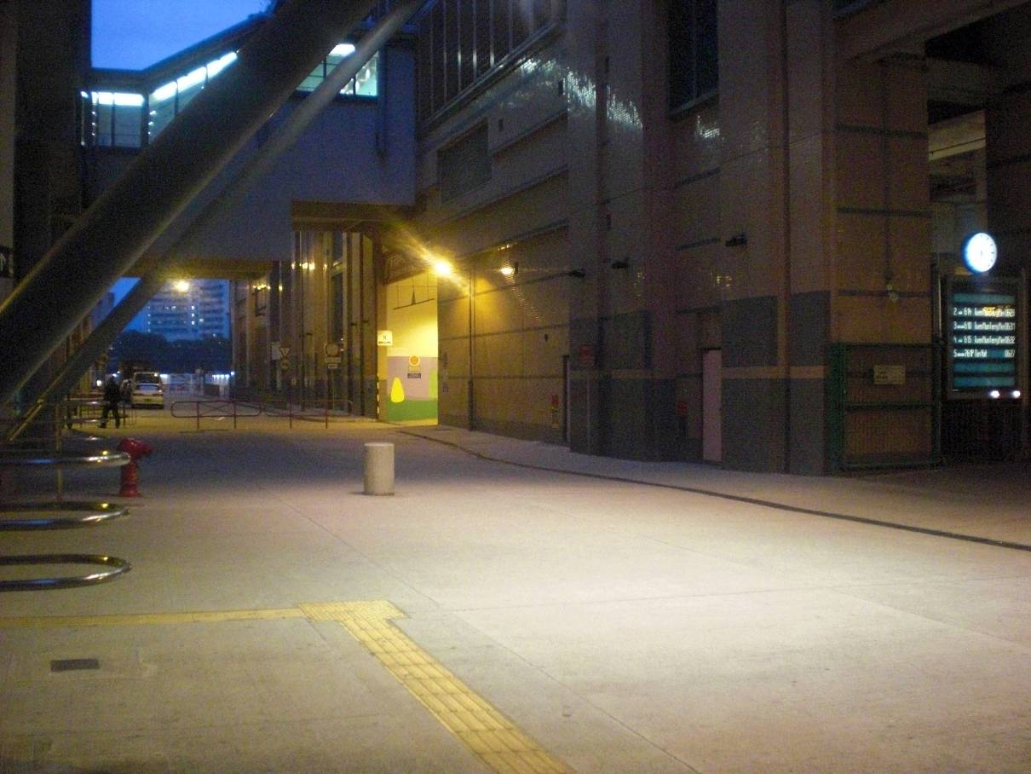
POH Shuttle Bus (DW 1015) is available at 08:45 & 09:15 on
12 MAY 2011 (THUR)

